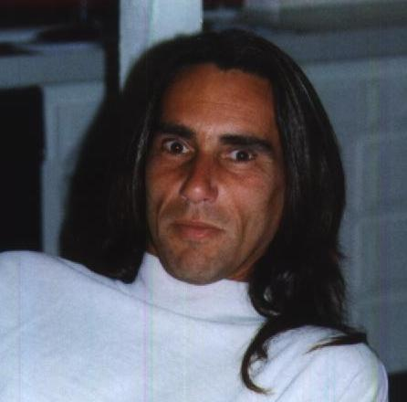
David Simon
27311 Park Vista Rd.
Agoura Hills, Ca, 91301
Phone 818-991-4121
Cell 818-292-2288
E-mail davidbsimon@hotmail.com
History | I began in the PC industry as a hobby in 1976 with the first “home PC’s” ever, the Altair 8080 and then the TRS-80 computers. By 1982 I was developing software for the then new IBM PC’s. I now have more than 30+ years of working with and programming PC’s. I am fluent in the C/ C++ and Java languages along with Assembler, Pascal and COBOL (all not used much any more). I am very familiar with all Windows operating systems and programming environments and DOS programming environment. I use and know well Microsoft Visual C++, Microsoft Visual BASIC, ASP/HTML and other web programming languages. These days most of my work is in JAVA or Objective-C (Android/IOS).
Work experience | 2014 - present Casamba Inc. - Writing Mobile (Android and IOS) versions of their desktop physical therapy and home health care apps.  2010 - present Mobilitie LLC mobile projects  - For the last four years I’ve been head developer of a new project/company at Mobilitie LLC where we’ve been installing wifi in large venues (including all nine MGM resorts Las Vegas properties) and creating mobile apps and back end servers and data collection/management for all users accessing these wifi networks. I’ve been doing the technical management of the development teams, product teams and also coding the POC versions of the apps. Wrote WiFi and peer to peer based communications systems and games and streaming video apps.  2012 - present Paydiant.com  - Wrote an Android tablet version (replacement, very cheap) for expensive Verifone POS (point of sale) and checkout terminals that also allow mobile phone payments. Also wrote mobile payment apps.  1986 – 2010 Elixir Technologies, Ventura, Ca.  - Designed, wrote and programmed several products for the high-speed laser printing market (specifically Xerox 9700, 4050 and 4850 printer and IBM 3800 and 3900 printers and Postscript and PDF languages).  - Currently designing/programming and maintaining additional products for high speed printing in the banking, insurance and tax processing industries. This includes forms design products, font-editing products, graphics editing products, document creation products and data merging applications (all PC Windows/Windows95/Windows NT based).  - I have worked extensively with many printing languages and written document, form and resource converters to/from most of these (including Xerox Centralized printers, AFP, PDF, PS, etc).  - I have design/written complete workflow systems for companies such as Travelers Ins, Wachovia, USAA, Moore, Fidelity and others.  2000 – 2006 RecordTV.com Inc.  - Create/Designed/Patented Internet/Network based PVR (personal video recorder) and formed RecordTV.com Inc. Developed highly distributed streaming video delivery methods to deliver relatively high quality streaming video to large numbers of users.  1984 - 1986 Software Design Associates, Agoura, Ca.  - Developer - Wrote commercial software for Sierra Online Software including accounting packages, word processors and games.
Education | 1977 - 1981 University of Michigan, Ann Arbor, Mi.  Undergraduate degree in Business and Computer Programming  1981 – 1984 Cal State University Northridge.  Graduate work in computer science
Special Skills | I understand fully document/forms creation, workflows, conversion, management and archival along with web site creation/distribution/data collection of forms and PDF. I also manage several large networks and servers.
About David Simon

I have been a software developer/programmer for about 30 years now and am competent in most development languages and environments. I started out writing games and business accounting software for Sierra On-line and for the last 22 years worked for a company (Elixir Technologies, www.elixir.com) developing/designing/programming forms/fonts/graphics/document formatting/printing/management software and am very familiar with high-speed printing environments (Xerox/AFP/IBM etc).

For the last 3 years I’ve been mostly doing mobile development on Android, IOS and Web, including Wifi based P2P communications, POS Android terminals and mobile payment apps.

I have also started several web based companies (RecordTV.com and some others).

I am most competent in C/C++, JAVA and HTML programming but have worked in many other languages as well (COBOL, BASIC, Fortran, ASP etc) and am very familiar with Windows environment, Windows servers and Windows networking (though I’ve also done Linux server work as well). I’m also very familiar with many databasing technologies including MySQL, Access and Sequel Server.

